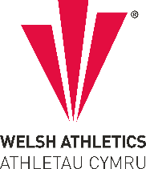
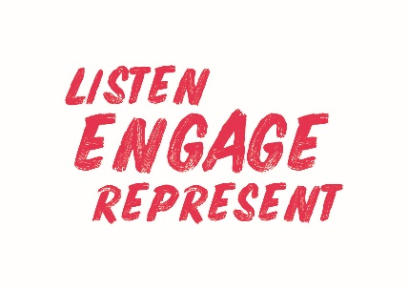
Welsh Athletics Endurance Officials Meeting Minutes
Held on the Monday 31 October 2022 6pm
Meeting held remotely via video link

Present:
Nigel Jones, Zoe Holloway, Paul Brooks, Jacqueline Brace, Alex Donald, Christine Vorres
Papers circulated in advance: Minutes of meeting held 8 August 2022.
Actions from meeting
Item Number | ACTIONS | Person responsible
3a | Nigel to formally write to James Williams to request an increase in petrol expenses paid to Officials | Nigel
3a | Zoe will contact Ann Philips (Danielle’s mum) as she is a Trans Gender tutor | Zoe
3a | Christine to email the officials to ask who needs a polo shirt. | Christine
3a | WA (draft) Governance Calendar to be emailed to committee members | Christine.
3b | Ascertain whether Officials awaiting their DBS can ‘shadow’ at meetings | Zoe

- Apologies for Absence Danielle Phillips
- Declaration of Interest - None declared
3. Discussion items
3a*Matters arising from previous Minutes.
Nigel spoke to James Williams regarding expenses but will put the request for an increase formally in writing
Zoe has handed out official’s polo shirts, some outstanding, but more shirts expected in February. Officials to be contacted to ask who needs one.
Ann Phillips will be contacted before the end of the year
3b Selection of Officials. Alex presented the meeting with a list of key officials and a list of Officials available for the Welsh Schools XC Champs and the Welsh XC Championships and the members discussed and allocated roles. Some newer volunteers are awaiting their DBS.
4. Discussion
a. Review of Officials Education Pathway – Levels 1-3
Zoe updated the meeting on the number of Officials in each region of Wales. 102 Licensed officials in Wales. The members discussed how to consult with the Officials community, and proposals to introduce fees for Officials courses. All members agreed a proposed fee of £10 for level 1 course and £10 for risk awareness – may be introduced in Apri 2023.

5. Correspondence – None

6. AOB
Nigel congratulated Christine for achieving an Award of Honour.
Christine asked the members for advice regarding medical cover risk assessments and the role of the Adjudicator. All agreed its an area that can be problematic and should be discussed with St Johns Ambulance, but that the Adjudicators role means that they are responsible only for checking that one exists for an event.
Jacqueline told the meeting that event licence applications were coming in thick and fast, and whilst numbers attending events is still lower than previously, events were still going ahead. Especially pleasing is that the Glyneath 5 is going ahead, now hosted by Adam Newton.
7. Date of Next Meeting
5th December 6pm.

